Alternative Assignment for Freshmen Swim Unit
Due Before the last day of the Swim Unit
Do a research project on a topic related to swimming or other aquatic activity. Ideas could include any of the following but are not limited to just these suggestions….
  - Swimming as a sport
  - Olympics
  - Records for swimming (IE fastest times, longest distance, etc.)
  - Fashion over the years in swim wear
  - Safety
  - As a form of exercise/workout
  - Types of strokes
  - Pool Etiquette
  - Different places to swim
  - Why it is important to know how to swim
  - Medical conditions that keep people from swimming

Your report can be a written essay….it should include a topic paragraph, 3 solid body paragraphs and a conclusion paragraph with any works cited used in your research and a visual aide to accompany your work.
You can do a power point presentation with a min. of 10 slides and a written summary of your information, along with a works cited page.
You can do a display board of your topic to present to the class at the end of the swim unit along with a written summary and works cited page.
You can come up with an original idea, just run it past your teacher first to get approval on your idea prior to starting.
Good luck and we look forward to seeing your work.
Missed a Day of swimming….Here is a make-up Assignment

Define the following terms in regards to swimming….

- Anchor

- Backstroke

- Blocks

- Deck

- Dual Meet

- Meters

- Stoke

- False Start

- Heats

10.Kickboard
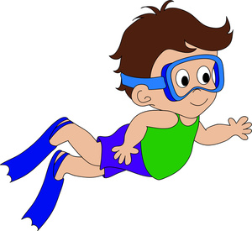
Missed a Day of swimming….Here is a make-up Assignment
Name: Date:
1. A stroke made in the prone position where both arms are lifted simultaneously out of the water and flung forward, in combination with the dolphin kick
A. Butterfly B. Flutter-kick C. Breaststroke D. Crawl
2. A stroke made in the prone position in which both hands move simultaneously forward, outward and rearward from in front of the chest, and the legs move in a frog-like manner
A. Dolphin kick B. Flutter-kick C. Medley D. Breaststroke
3. A stroke in which the swimmer is on his back performing a flutter-kick and rotating the arms alternately backward
A. Breaststroke B. Backstroke C. Flutter-kick D. Medley
4. An event where the swimmers may use any stroke they choose, which typically is the crawl
A. Dolphin kick B. Crawl C. Freestyle D. Butterfly
5. A kick, usually performed as part of the crawl, where the legs are held straight and moved up and down alternately
A. Breaststroke B. Flutter-kick C. Medley D. Butterfly
6. A start in which one or more swimmers leaves the blocks before the starting signal
A. False start B. Medley C. Flutter-kick D. Butterfly
7. A combination event in which a swimmer or relay team swims separate legs of backstroke, breaststroke, butterfly and freestyle
A. Medley B. Dolphin kick C. Breaststroke D. Backstroke
8. A kick where the legs are held together and moved up and down by bending and straightening them at the knee twice in quick succession
A. Crawl B. Butterfly C. False start D. Dolphin kick
9. A stroke made in the prone position characterized by alternate over arm movements and a continuous up-and-down kick
A. Backstroke B. Medley C. Crawl D. Freestyle
Missed a Day of swimming….Here is a make-up Assignment
Name: Date:

.
___Oxygen A…..The portion of the central nervous system that is located within the skull.
___Heart B…..A life-saving emergency procedure that involves breathing for the victim and applying external chest compression to make the heart pump.
___Circulation C…..The movement of fluid through the body in a regular or circuitous course.
___Pulse D…..The muscle that pumps blood received from veins into arteries throughout the body
___Fibrillation E…..The odorless gas that is present in the air and necessary to maintain life.
___Airway F…..The rhythmic dilation of an artery that results from beating of the heart.
___Resuscitation: G…..The procedure of restoring to life, as in cardiopulmonary resuscitation (CPR).
___Brain H…..In cardiology, an abnormal and erratic twitching of the heart muscle
___Cardiopulmonary Resuscitation I…..The process of respiration, during which air is inhaled into the lungs through the mouth or nose due to muscle contraction and then exhaled due to muscle relaxation.
___Breathing J…..The path that air follows to get into and out of the lungs

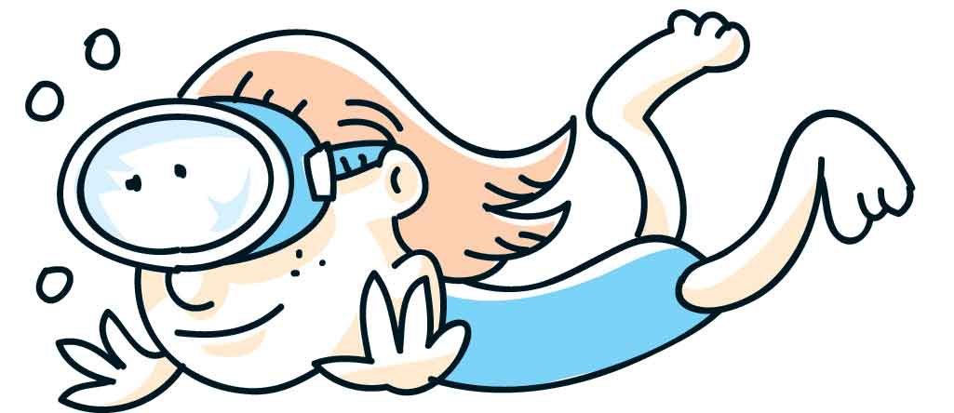
Missed a Day of swimming….Here is a make-up Assignment
Name: Date:

How many Olympic Gold Medals does Michael Phelps have? _______
How many overall Olympic Medals does Michael Phelps have?_________
How many Olympic Gold Medals does Jenny Thompson have?________
How many overall Olympic Medals does Jenny Thompson have?_________________________
Who holds the 50m freestyle Olympic record set in 2008 in Beijing, China?_____________________
What time did Ranomi Kromowidjojo swim in 2012 to set the Olympic 50m freestyle record?______________
What country holds the Olympic record for the men’s 4x100 medley relay?____________
What country holds the Olympic record for the women’s’ 4x100 medley relay?____________
Who is the first and only swimmer to represent the United States in five Olympic Games (1984, 1988, 1992, 2000 and 2008)______________
At age 41, who was the oldest swimmer ever to earn a place on the U.S. Olympic team?_______________________

Missed a Day of swimming….Here is a make-up Assignment
Name: Date:

Fill in the Blank.

1. Freestyle and backstroke use a _____________________ kick.

2. Name the two strokes where the face is out of the water and the ears are in the water:

________________________________ and __________________________________.

3. The 4th most common cause of death from unintentional injury is ______________________.

4. A ________________ kick is used when executing the elementary backstroke.

5. For safety reasons, no one should be diving into water ___________________ in depth or less.

6. A kick that is not recommended for treading water is the _____________________ kick, because it expends too much energy from the body.

7. “Monkey, airplane, soldier” refers to the ____________________________stroke.

8. The highest drowning rates are with young adults ages ______ to ______, and
children under age _______.

9.Name a rule in the pool area._____________________________________

10.You cannot go off of the diving board until the last person puts their ____________on the side of the pool.

Missed a Day of swimming….Here is a make-up Assignment
Name: Date:

True or False (write the word)

1. ____________ Your eyes should be above the water line and looking forward during the
prone glide.

2. ____________ In the streamlined position, the arms and legs are fully extended and

the toes are pointed.

3. ____________ The elementary backstroke sequence is: “monkey, airplane, soldier” or

“up, out, together.”

4. ____________ Survival floating wastes energy and should not be used to wait in the water.

5. ____________ Most drowning victims do not yell for help.

6._____________It is ok to jump in the 3 foot deep end of the pool.

7._____________You may not have food or glass in the pool area.

8._____________If you are not dressed you may leave 10 min. early.

9._____________To get your full credit you only need to sit on the side of the pool.

10.____________To pass the swim unit you must jump off of the diving board and touch

The bottom.

